Introduction

The main idea of this assignment was to create a Weather Application. This application connects to Open Weather API using an AJAX Request and parses the returned XML Data into meaningful data that is useful for users when they launch the website.

Project Requirements

Connect to Openweathermaps.org using an AJAX Request

Parse the returned XML data in a meaningful way

Project Challenges

Parse the XML data in the correct manner and demonstrate them in a beautiful and elegant way on the website.

Getting the charts right decently.

Making the UI look neat and tidy.

Features

Displaying the current weather

* Temperature
* Date
* Corresponding Icons
* City, Country
* Sunrise and Sunset time
* Wind Speed and Humidity

Displaying the min and max temperature for the coming 5 days.

* Day
* Weather( icons + weather value)
* Min-max Stacked bar graph (Horizontal)

Search Forecast for your own desired City

* Search Box

Toggle Button to change metric from Celsius to Fahrenheit

* Using a slider (Essentially a slider)

Animated Tabs on the top

* Current Weather
* Charts
* Compare City

Displaying Chart of Temperature vs Time for the next 24 hours

Displaying Chart of Humidity vs Time for the next 24 hours

Comparison between cities by inputting two Cities to get current weather data for each city

Add City on the main page

* Removes the last city and adds the new in the first place
* Different Icons for different cities
* Can Forecast of that city by clicking on each icon

How the Requirements were met

var url = "https://api.openweathermap.org/data/2.5/weather?q=" + city + "&appid=" + appkey + "&mode=xml&units=" + metrics;

  var request = new XMLHttpRequest();

  request.onreadystatechange = function () {

    if (this.readyState == 4 && this.status == 200) {

      var data = request.responseXML;

  }

  };

  request.open("GET", url, true);

  request.send();

This essentially is the way the application connects to the Openweather API and requests the XML Data. Here, we are receiving the xml data and parsing it and storing it in data.

The following code snippet will essentially call a function to display only the current weather data.

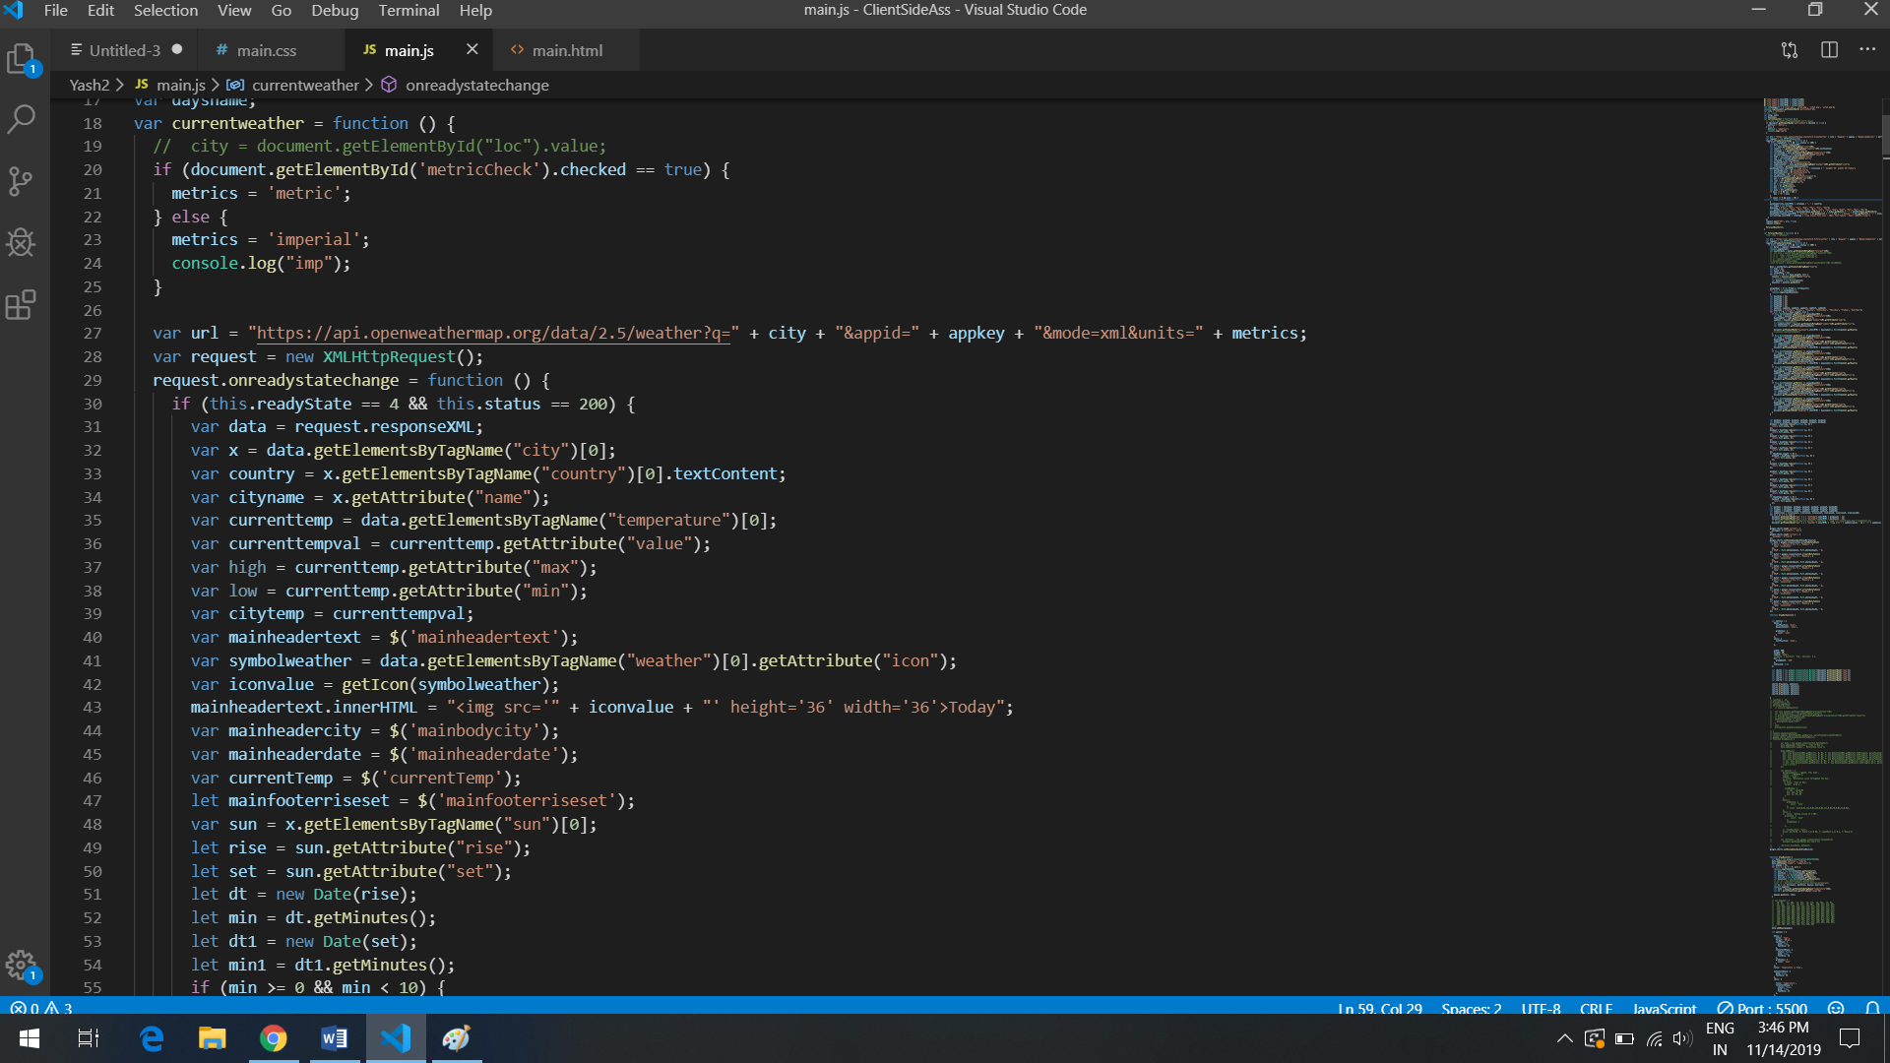

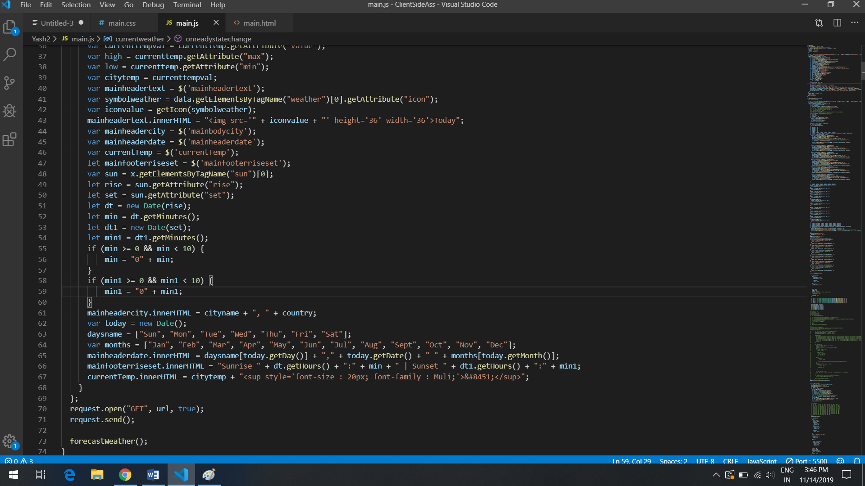

Here, we are receiving the XML data from the openweathermaps website. Now the data is being dealt with and using local variables, the data that the UI demands is being extracted and stored.

Data like Time, Temperature, Cityname, Country, Sunrise, Sunset elements are extracted from the XML data and are being injected into the HTML Elements with the help of DOM Scripting. Basically, for example, I want to extract the current temperature, l use

var currenttemp = data.getElementsByTagName("temperature")[0];

var currenttempval = currenttemp.getAttribute("value");

So the temperature value is stored in the currenttempval variable. Now we want to display this in the HTML page, hence we use

currentTemp.innerHTML = citytemp + "<sup style='font-size : 20px; font-family : Muli;'>&#8451;</sup>";

Here the currentTemp is the html heading element and using dom scripting, we are injecting the data in that heading.

Forecasting the next 5 days

When the API is called for the forecast, the xml data basically has 40 arrays of time which stores all the essential information. Now we will do all the tasks using these arrays.

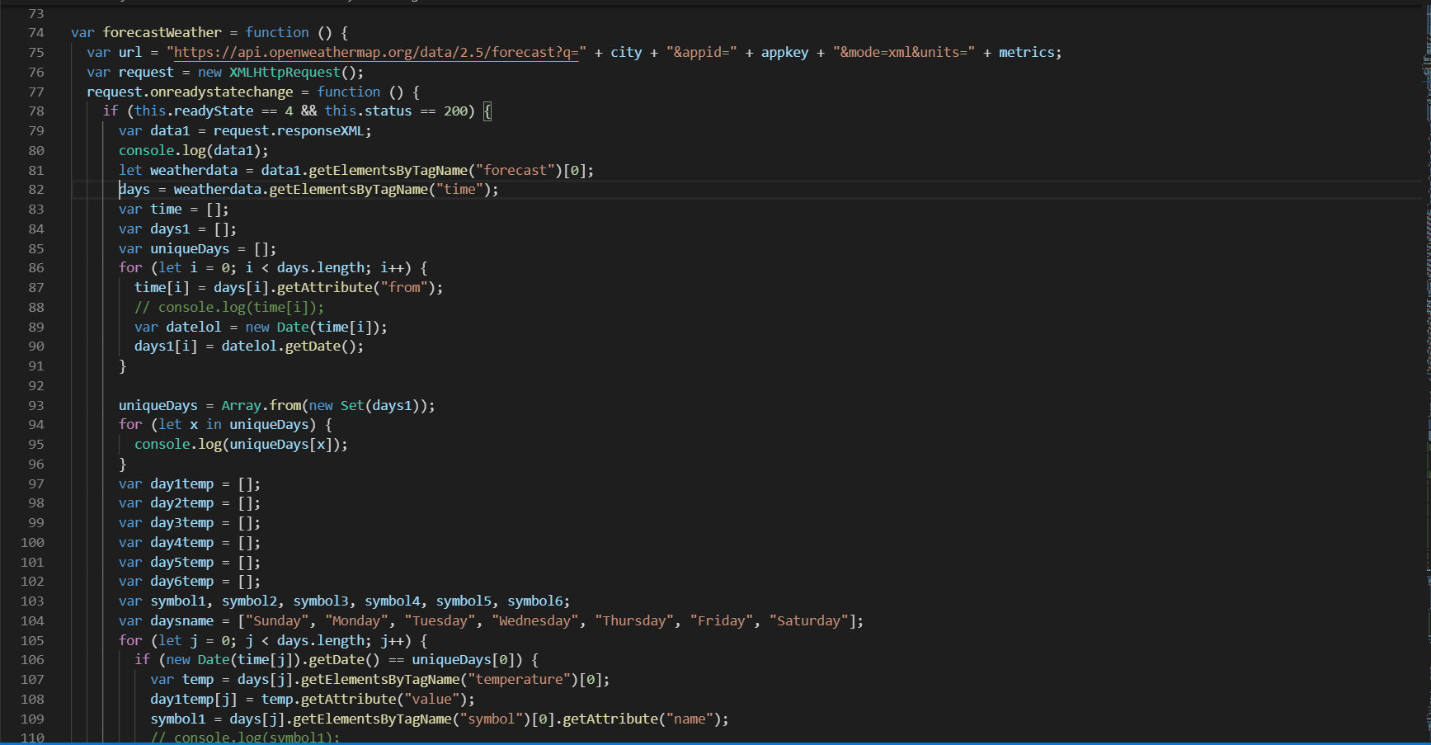

Now the logic is pretty simple. The first task in hand is segregate them according to the dates. So using a for loop, we are storing all the dates in the array days1.

Now we must get all unique days, i.e. remove all the repetitive days in the day1 array and store it in uniqueDays array. Using another for loop, we are going to match the date of a said time array and the date of the uniqueDays. Lets say today date is 16th Nov, we are going to match the date of the time array with 16th Nov and store its temperature, symbol name which is a description of the weather and the weather icon. All this data is stored in arrays specially made for all 6 days.

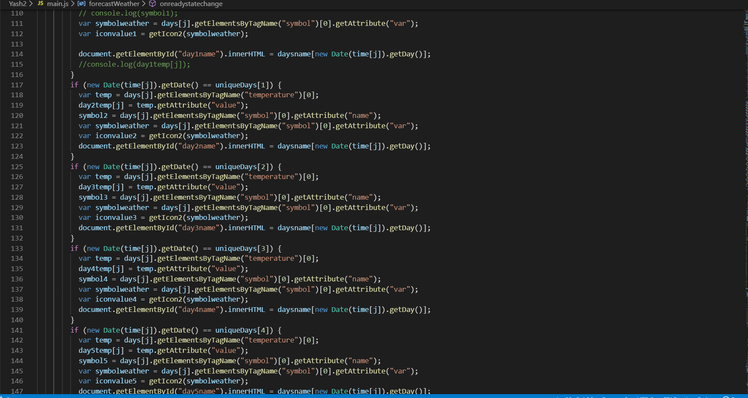

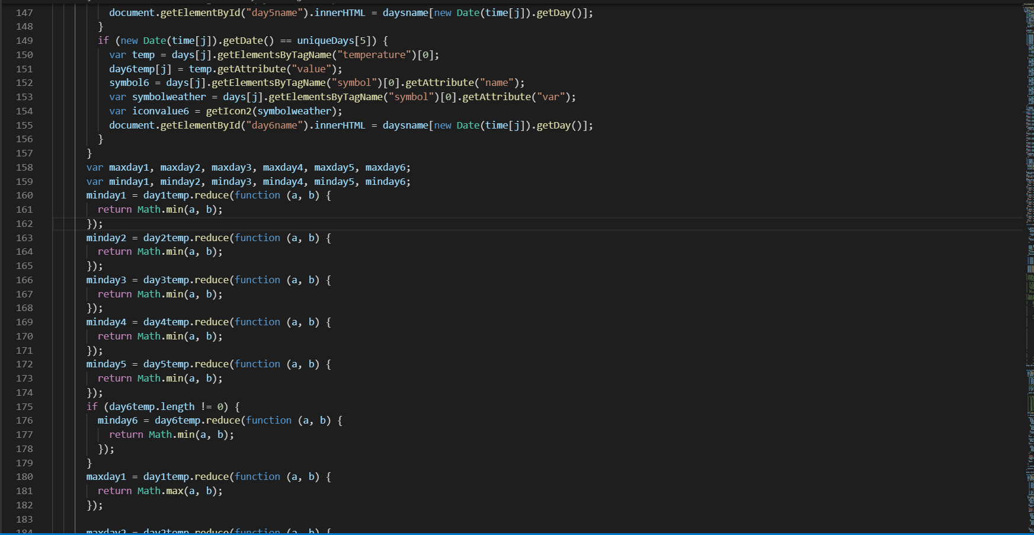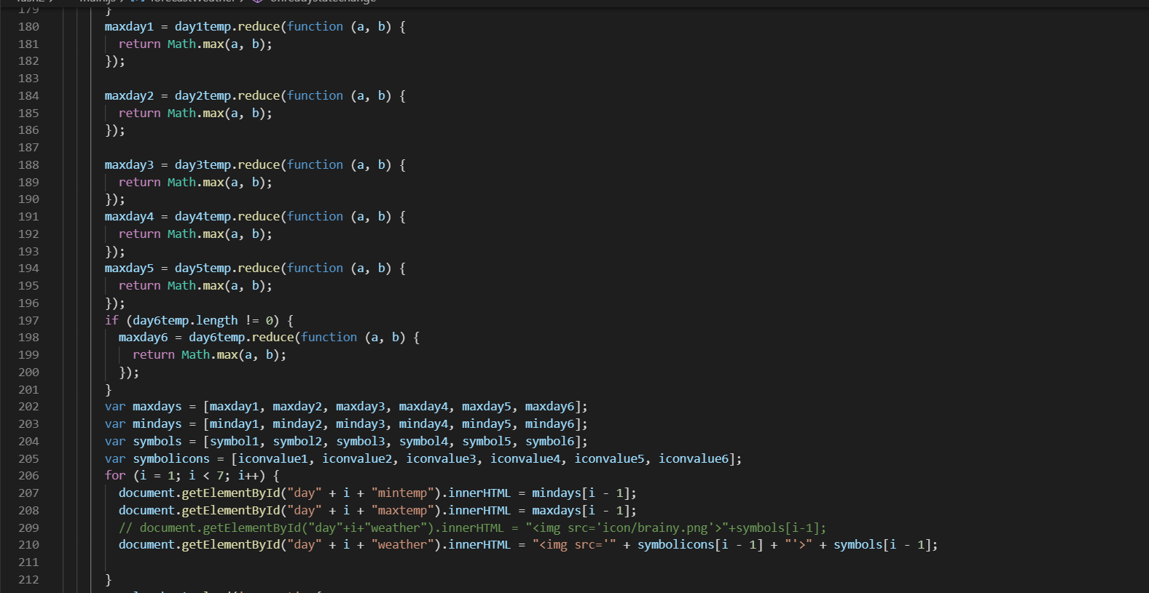

Now using different variables, we store min and max values for each day out of each day’s array and store it and inject it into the html.

Now using this, we are going to show how we made the stacked bar graph for min-max for each day.

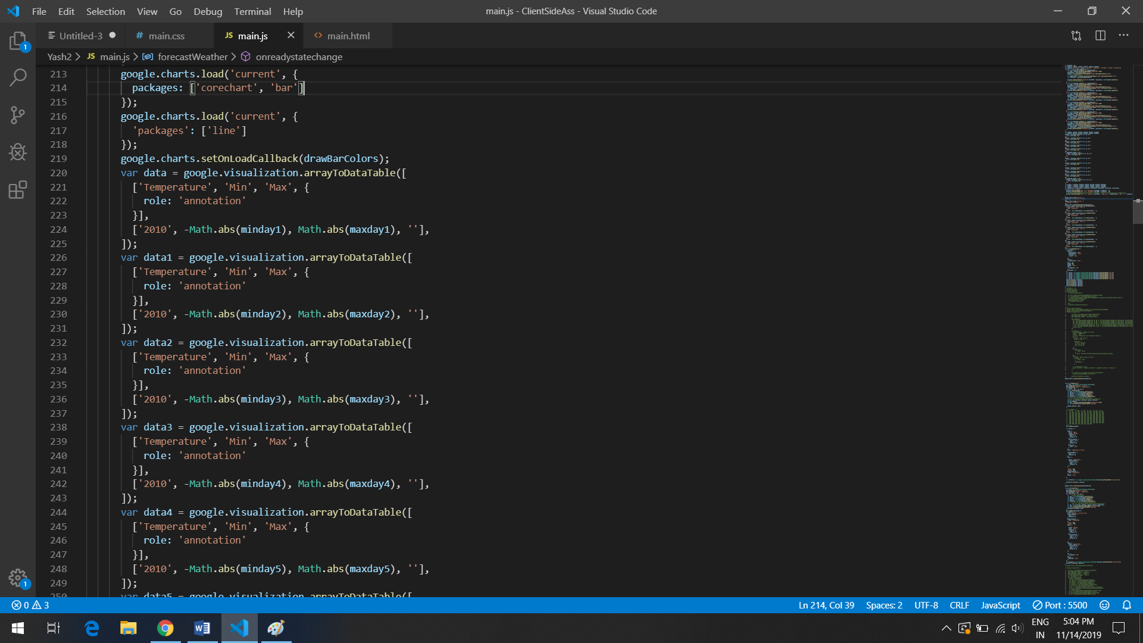

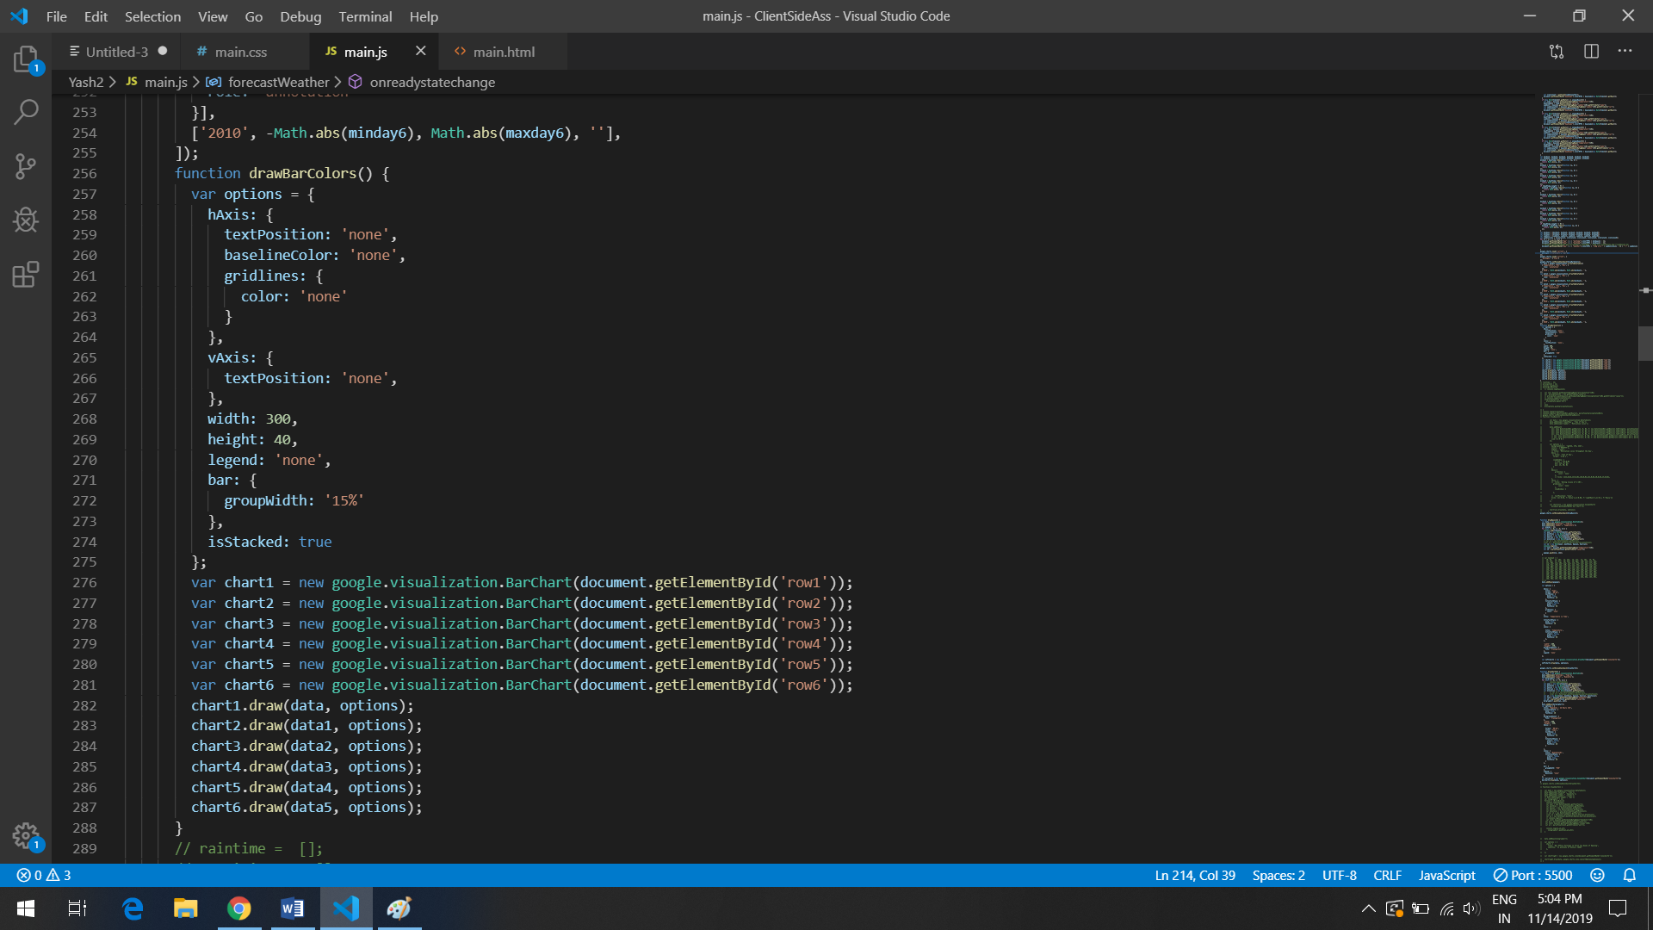

So basically we create different dataset with columns Temperature, Min, Max. Google chart tools are powerful, simple to use, and free. Google charts  provides a variety of charts designed to address your data visualization needs. These charts are based on pure HTML5/SVG technology (adopting VML for old IE versions), so no plugins are required. All of them are interactive, and many are pannable and zoomable.

All charts are customizable using the var options where you customize the haxis and vaxis labels. Now to draw the chart, we must first define a Html element where we want to draw the chart and assign a id. To create we simply use

new google.visualization.BarChart(document.getElemenetByID(“”));

The Google Visualization JavaScript API lets you access structured data and visualize that data using JavaScript in your web pages. The Google Visualization API also enables the creation of gadgets.

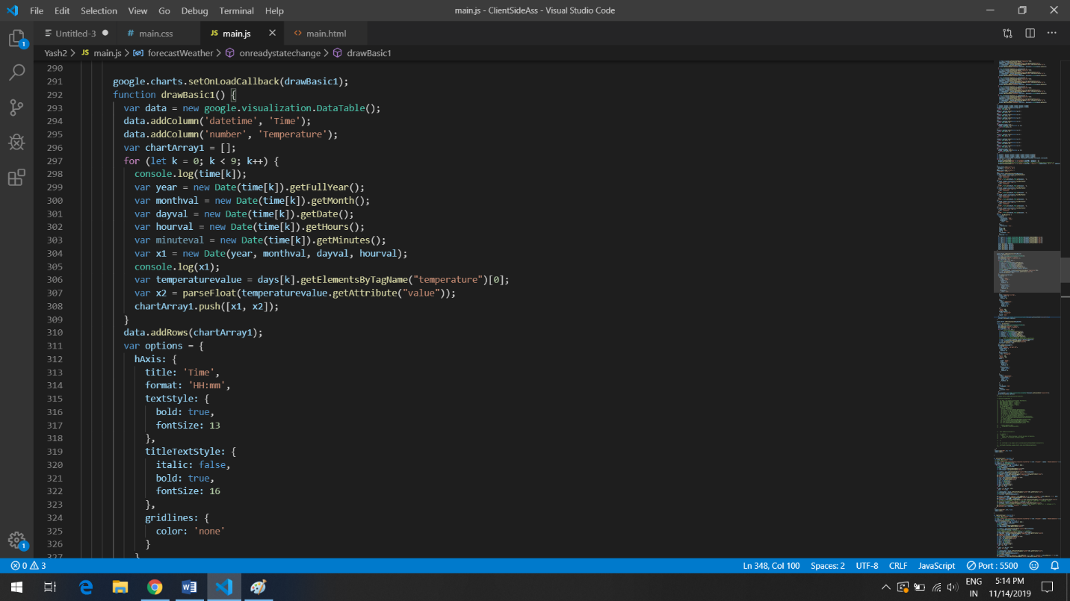Since we are talking about charts, Lets continue to detail the logic for the other two charts. 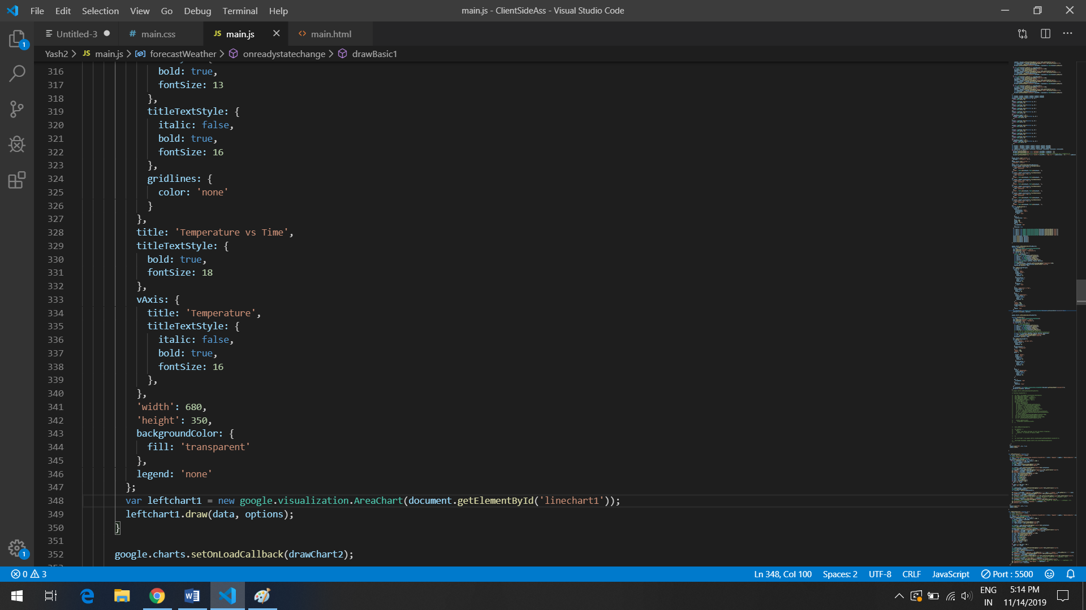

This chart is a AreaChart again by google charts api. Here we are using the same time[] array that stores the time arrays and use it to get information for the next 24 hours. So the format for the data columns is datetime, number.

Heres the tricky part, your data of datetime must be of the format

Year,month,date,hours,minutes. So the challenge was to extract that and push it into an array. Now we have made a variable chartArray to store values datetime and number. So it will be an array with nested arrays storing [date,number].

var leftchart1 = new google.visualization.AreaChart(document.getElementById('linechart1'));

        leftchart1.draw(data, options);

This creates our Area Chart.

Similarly, Bar Chart for Humidity vs Time has been created.

Comparison Feature

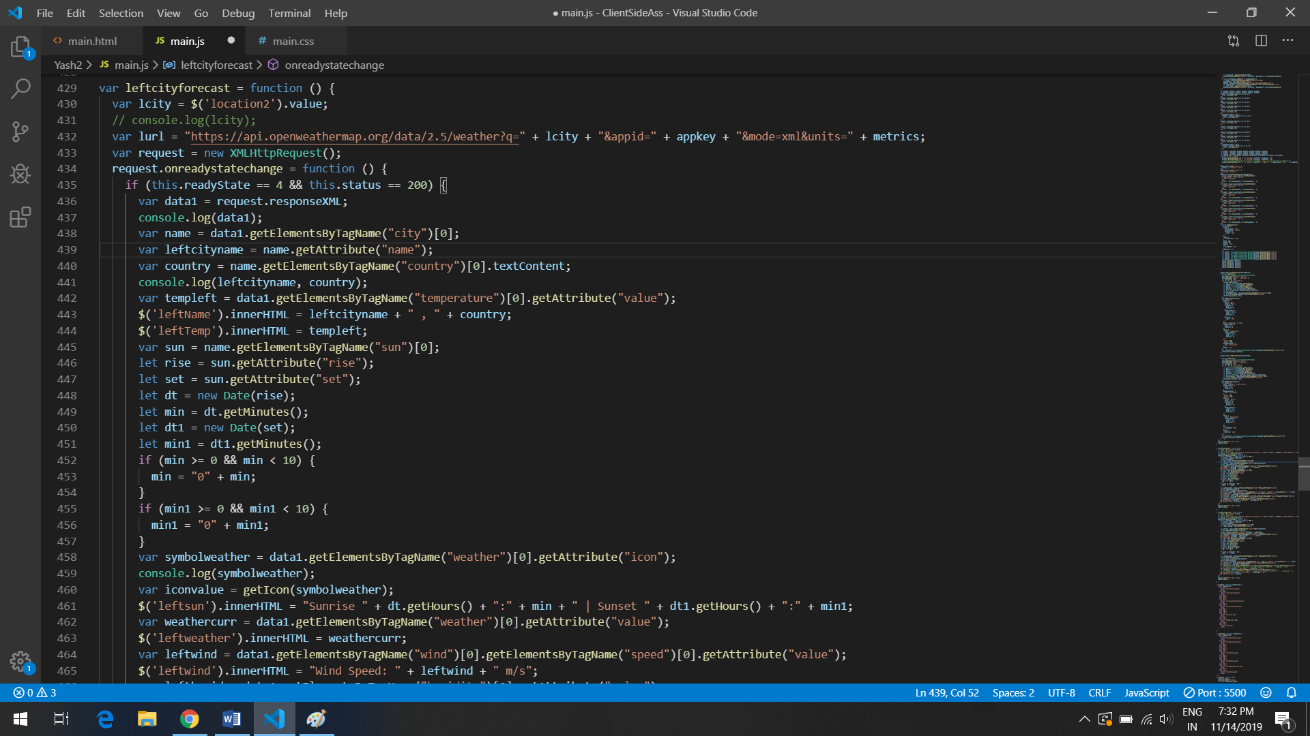

Here the logic is same, we are just calling two separate functions for both cities and getting new values for each city and parsing the data and displaying them in cards in the Comparison tab.

Icons

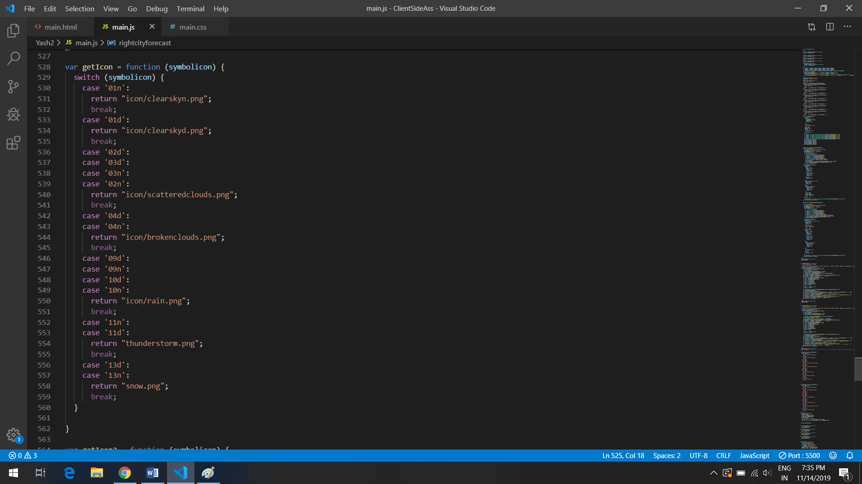

This is a simple function that returns the URL of the icons whenever this function is called. So basically, all the icons in the web application is being displayed because of this function.

Adding your own City

var cityarray = ['Athlone', 'Galway', 'Limerick', 'Dublin'];

$('city-name1').innerHTML = cityarray[0];

$('city-name2').innerHTML = cityarray[1];

$('city-name3').innerHTML = cityarray[2];

$('city-name4').innerHTML = cityarray[3];

var cityimagearr = ['city1.png', 'city5.png', 'city3.png', 'city4.png'];

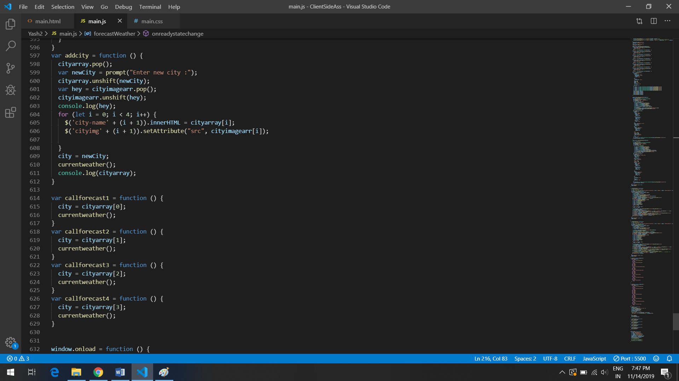

To make this possible, we are creating a default global array for city names and images. Now whenever user clicks on add City Button, you are prompted to enter your new City. So the logic is that the last value of the arrays is getting out and the new value is inserted in the first place. You can click on any city and the forecast changes.

Toggle between Celsius and Fahrenheit

var metrics;

if (document.getElementById('metricCheck').checked == true) {

    metrics = 'metric';

  } else {

    metrics = 'imperial';

 }

Basically the slider or the toggle button is a checkbox. If its checked I change the variable name metrics to a value and call the function again so that the metrics are changed immediately.

HTML Page

The header or tabs part of my html page

<header>

        <div class="tabs">

            <a class="active tablinks underlined" onclick="openCity(event, 'box1')">Current Weather</a>

            <a class="tablinks underlined" onclick="openCity(event, 'box2')">Weather Charts</a>

            <a class="tablinks underlined" onclick="openCity(event, 'box3')">Compare City</a>

          </div>

      </header>

 <script>

          function openCity(evt, cityName) {

  // Declare all variables

  var i, tabcontent, tablinks;

  // Get all elements with class="tabcontent" and hide them

  tabcontent = document.getElementsByClassName("tabcontent");

  for (i = 0; i < tabcontent.length; i++) {

    tabcontent[i].style.display = "none";

  }

  // Get all elements with class="tablinks" and remove the class "active"

  tablinks = document.getElementsByClassName("tablinks");

  for (i = 0; i < tablinks.length; i++) {

    // tablinks[i].className = tablinks[i].className.replace(" active", "");

    tablinks[i].classList.remove("active");

  }

  // Show the current tab, and add an "active" class to the button that opened the tab

  document.getElementById(cityName).style.display = "block";

  evt.currentTarget.className += " active";

}

      </script>

So basically all the elements are given the same class and if its active, a different css property is assigned. Animations are also added to this.

.tabs {

    position: absolute;

    top: 50%;

    left: 50%;

    transform: translate(-50%, -50%);

}

.tabs a {

    height: 35px;

    padding: 5px;

    margin: 35px;

    margin-top: 45px;

    color: black;

    cursor: pointer;

}

.underlined {

    color: black;

    font-size: 18px;

    /\* background-image: linear-gradient(to right, yellow 0, yellow 100%); \*/

    background-image: linear-gradient(to right, rgb(44, 176, 224), rgb(25, 79, 139));

    background-size: 0 100%;

    background-position: 0 1.6em;

    background-repeat: no-repeat;

    transition: background 1s;

  }

  .underlined:hover {

    background-size: 100% 100%;

    /\* color: white; \*/

    transition: all 2s;

  }

  .active {

    background-size: 100% 100%;

  }

  /\* Style the tab content \*/

  .tabcontent {

    display: none;

    padding: 6px 12px;

    border-top: none;

    position: absolute;

    height: 80%;

    width: 75%;

    top: 50%;

    left: 50%;

    transform: translate(-50%, -50%);

    border-radius: 15px;

  }

So there’s a main container that holds 3 divisions namely box1, box2, box3.

Box1 holds the main page. It shows the current weather, the 5 day min max temperatures, 4 cities, buttons, add city button and a toggle button to switch between Celsius and Fahrenheit.

Box2 holds the charts. It shows the Area chart for the city that is chosen that depicts the temperature vs time for the next 24 hours.

The Bar chart shows the Humidity vs Time for the next 24 hours.

Box3 holds the comparison page. Here, you enter two cities you want to compare and the corresponding data is shown.

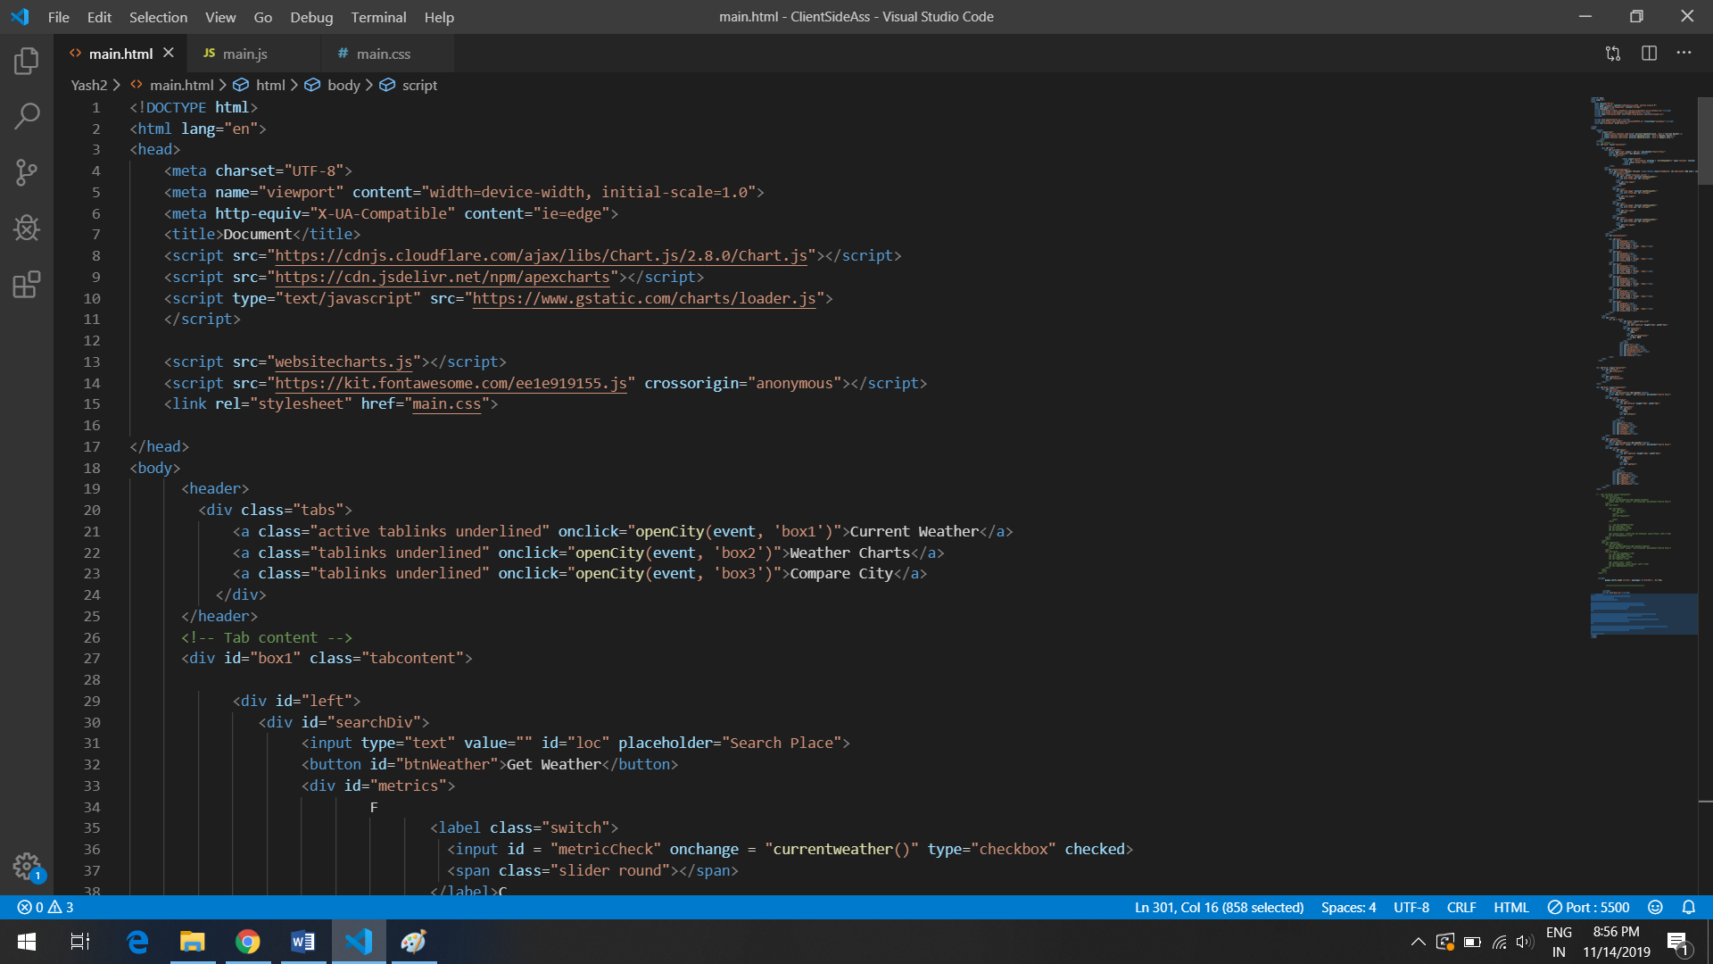

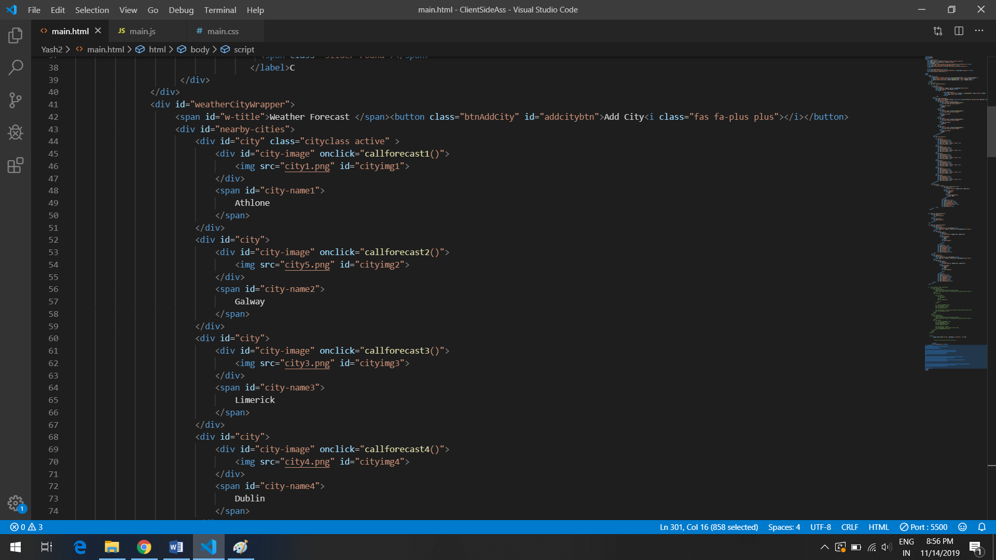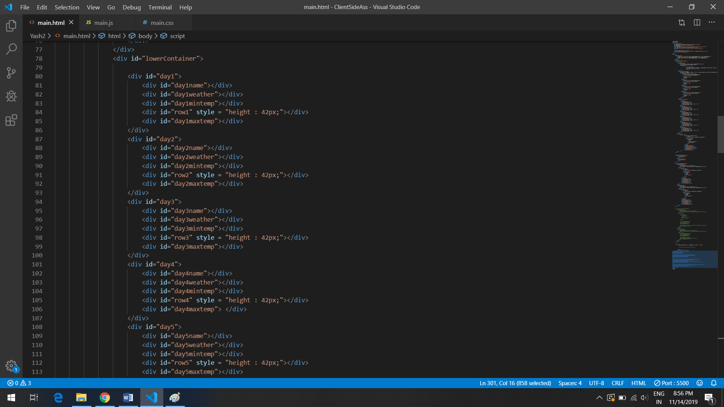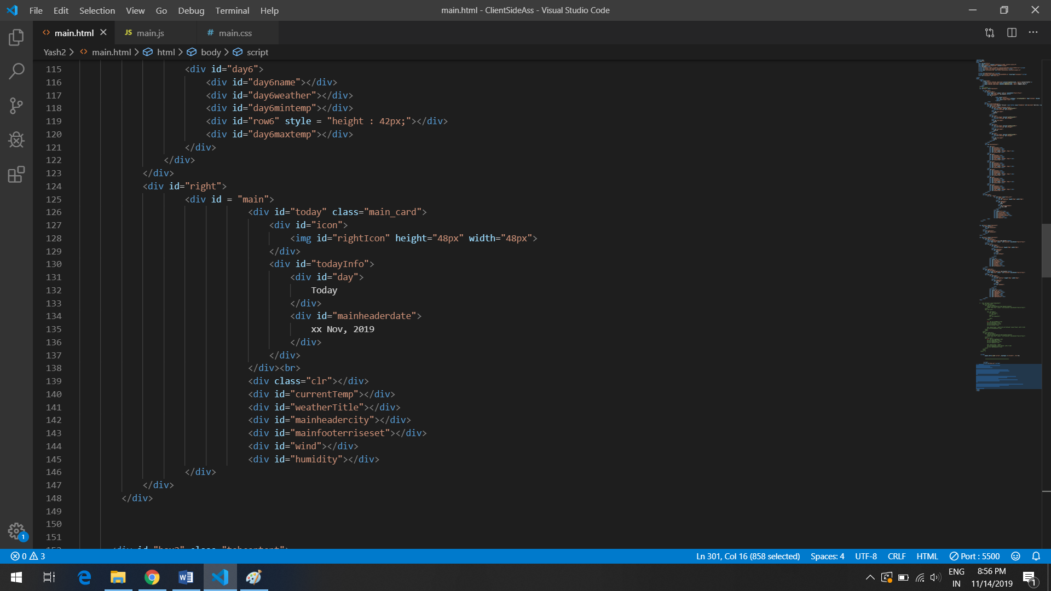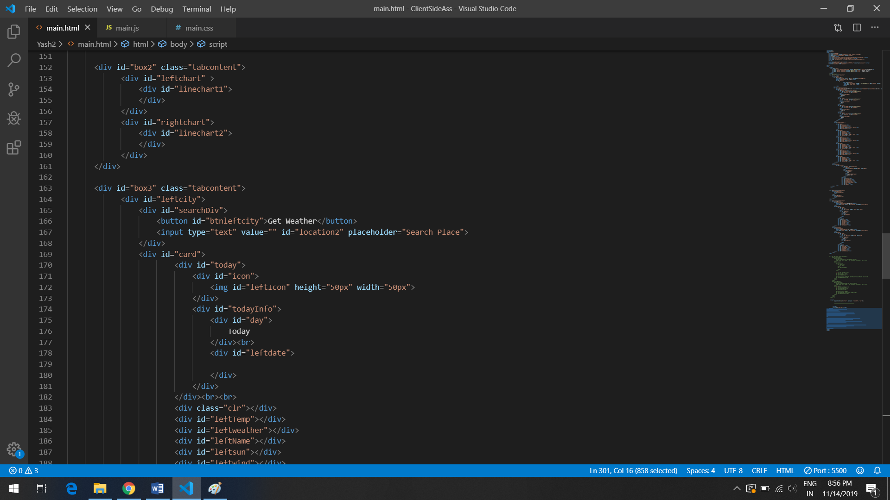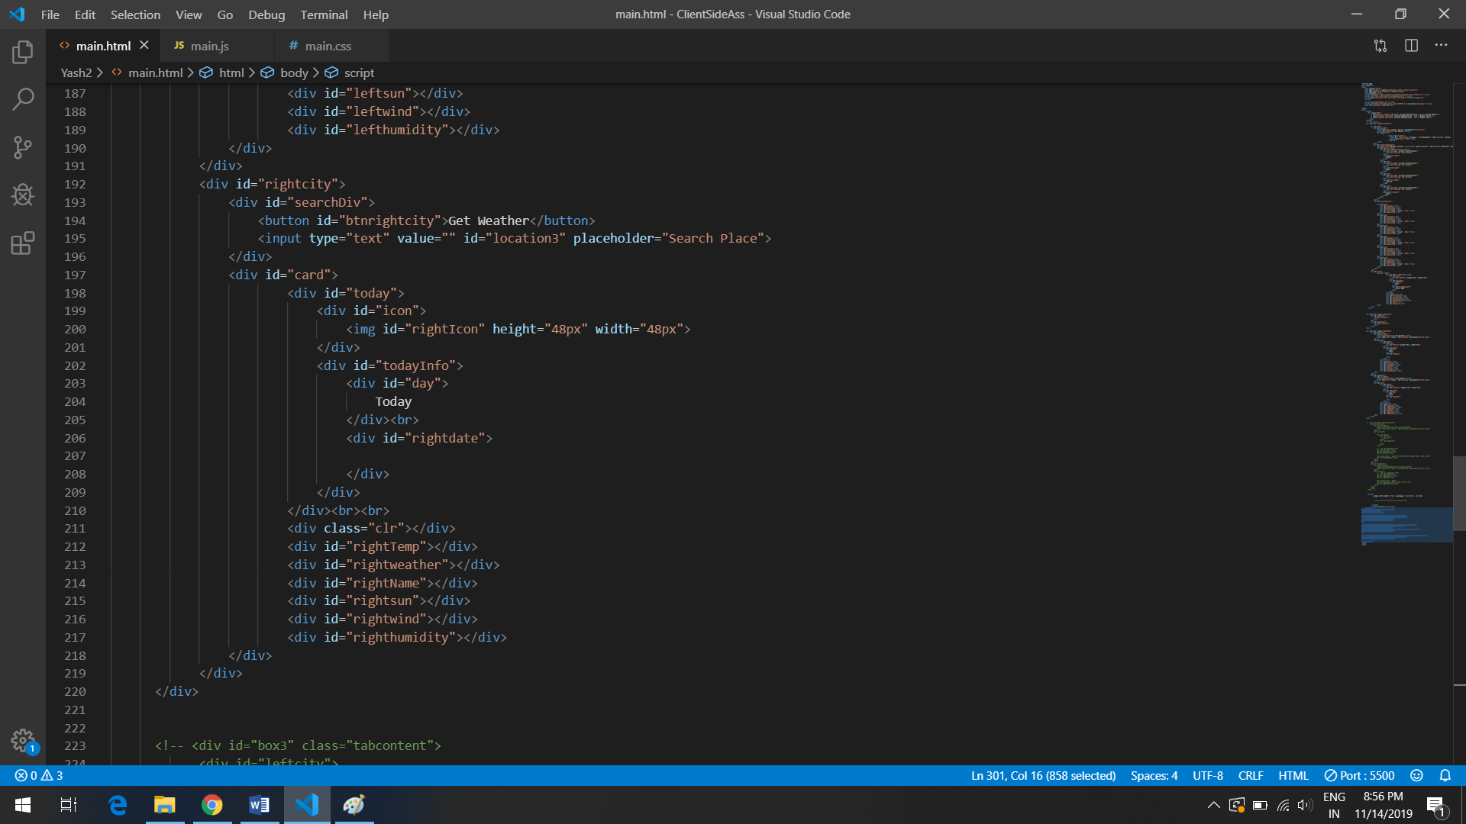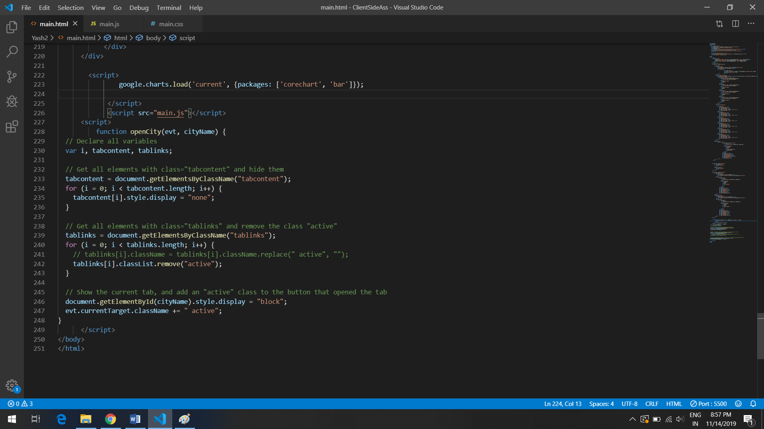

Style.css

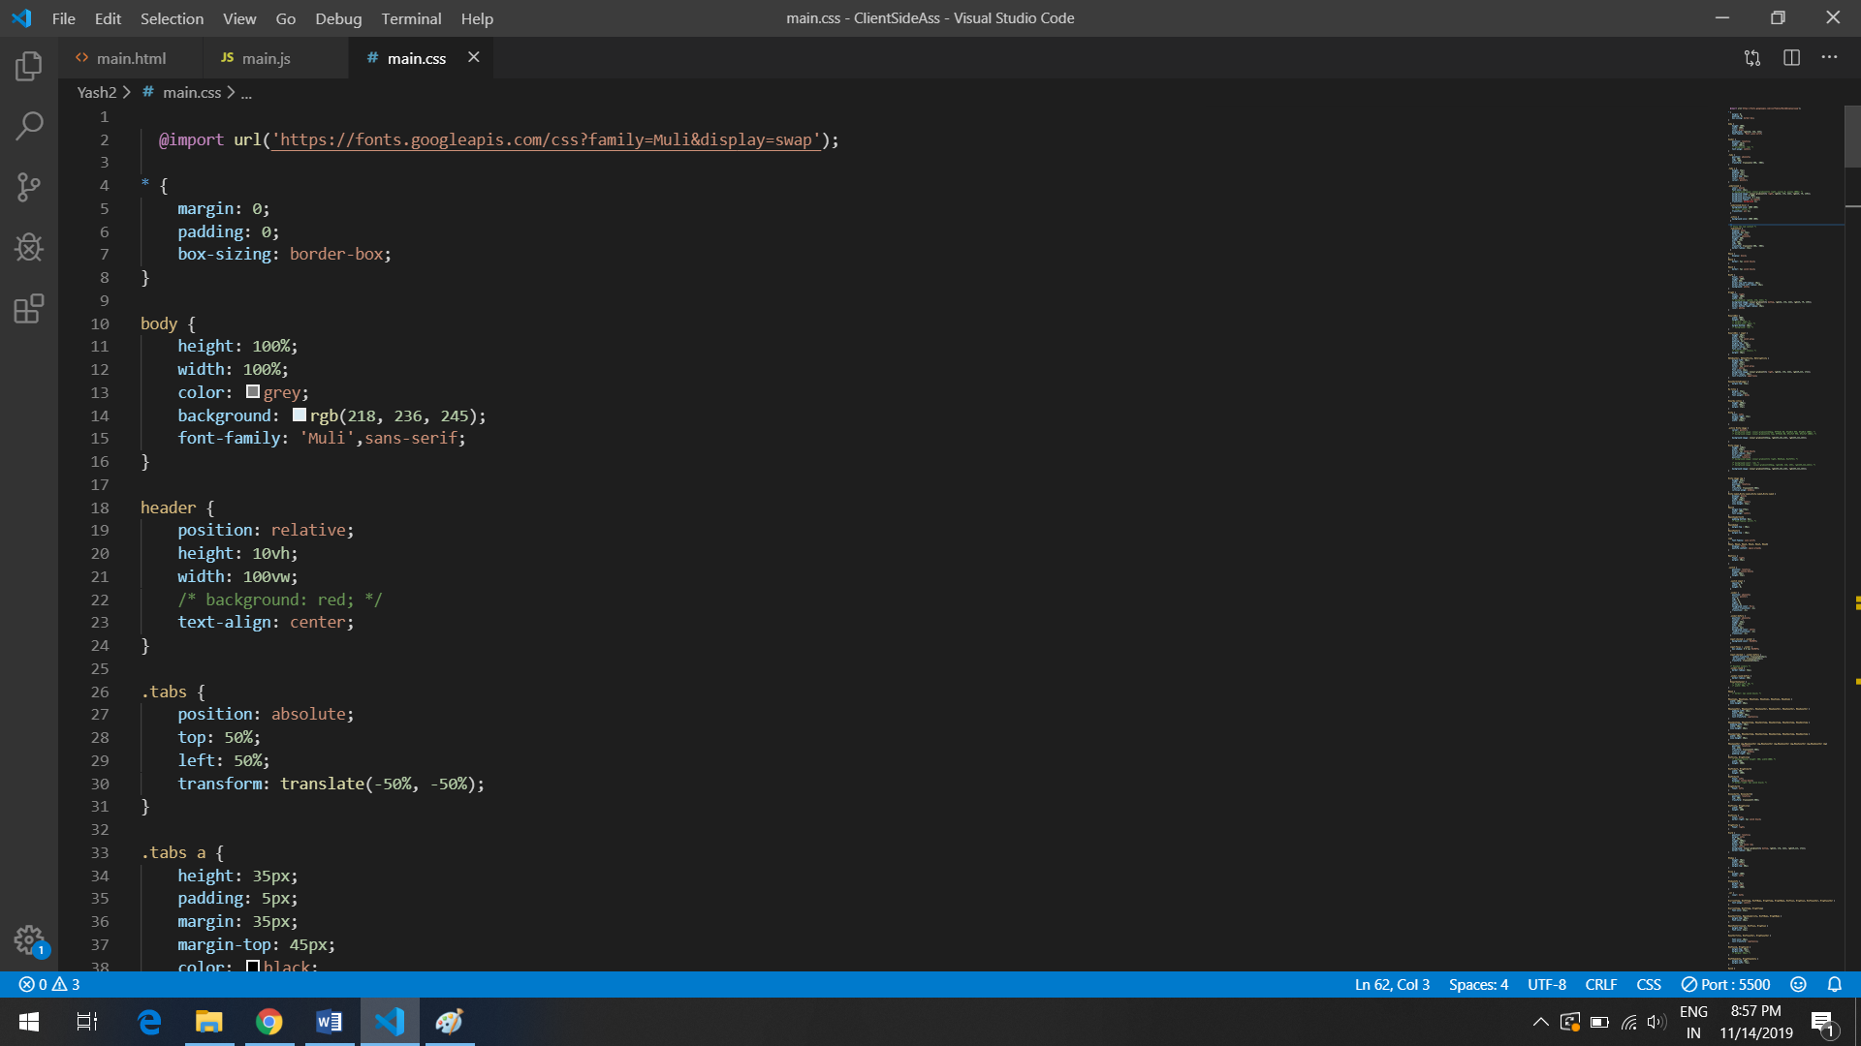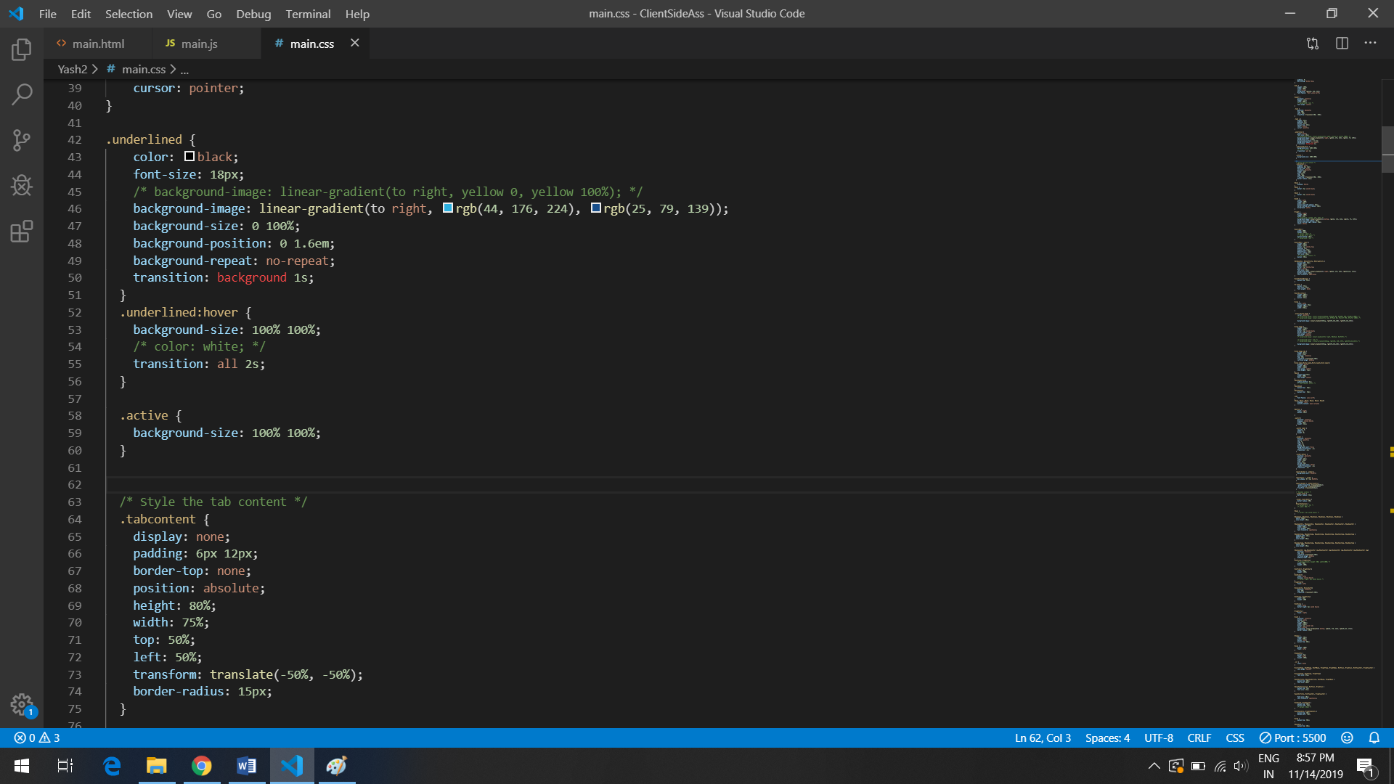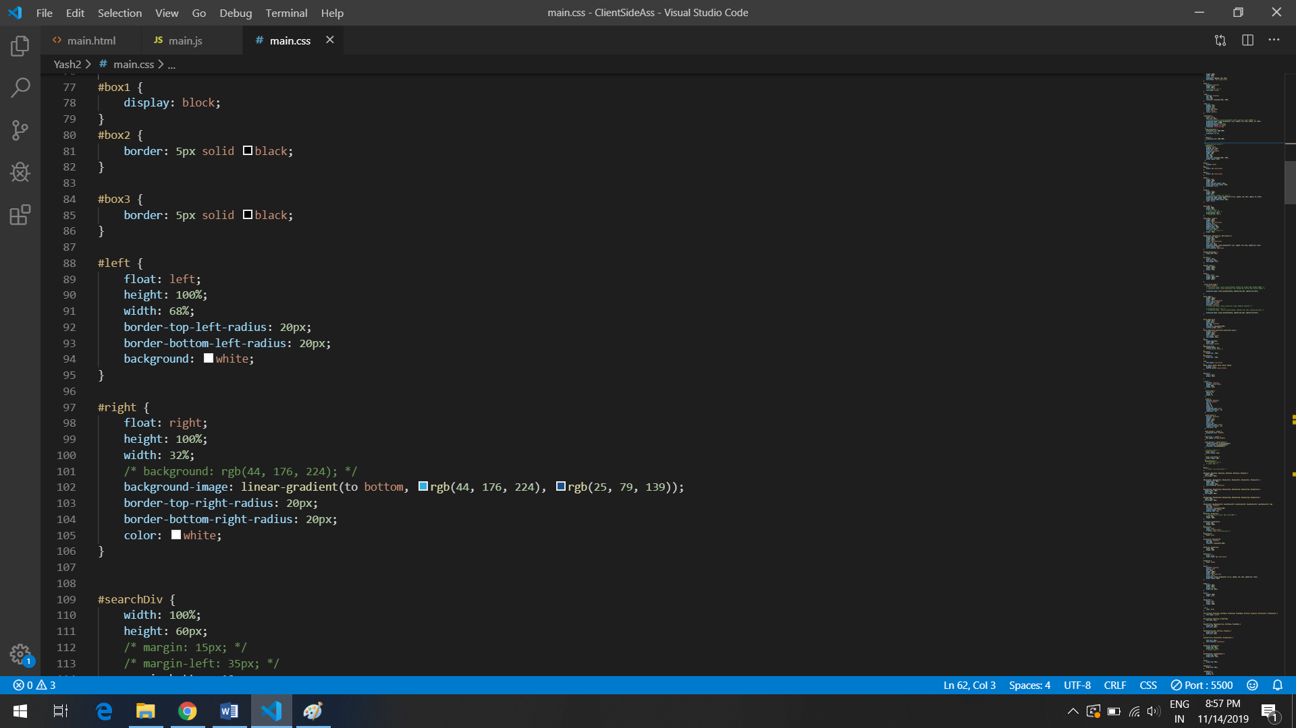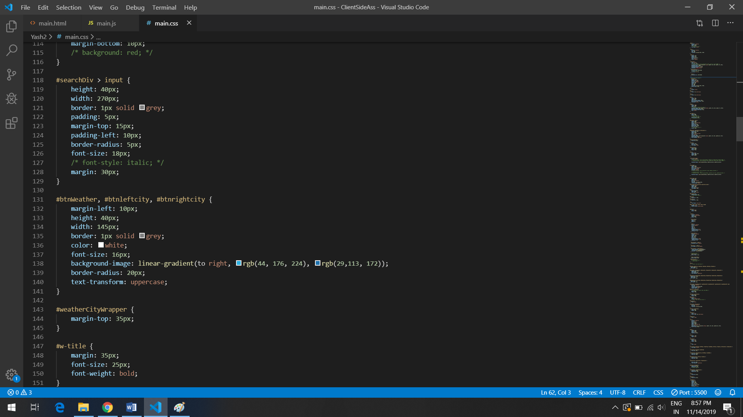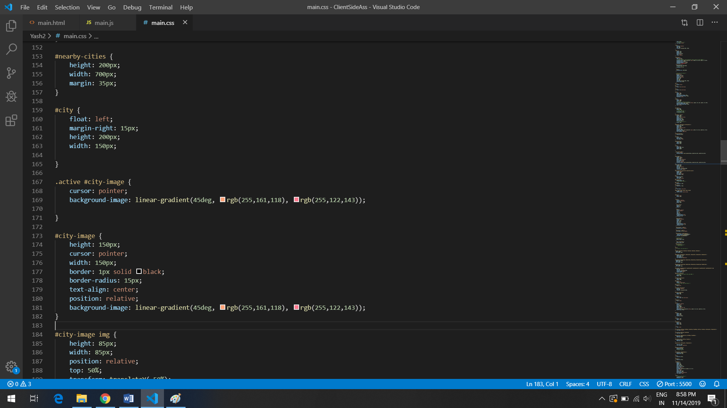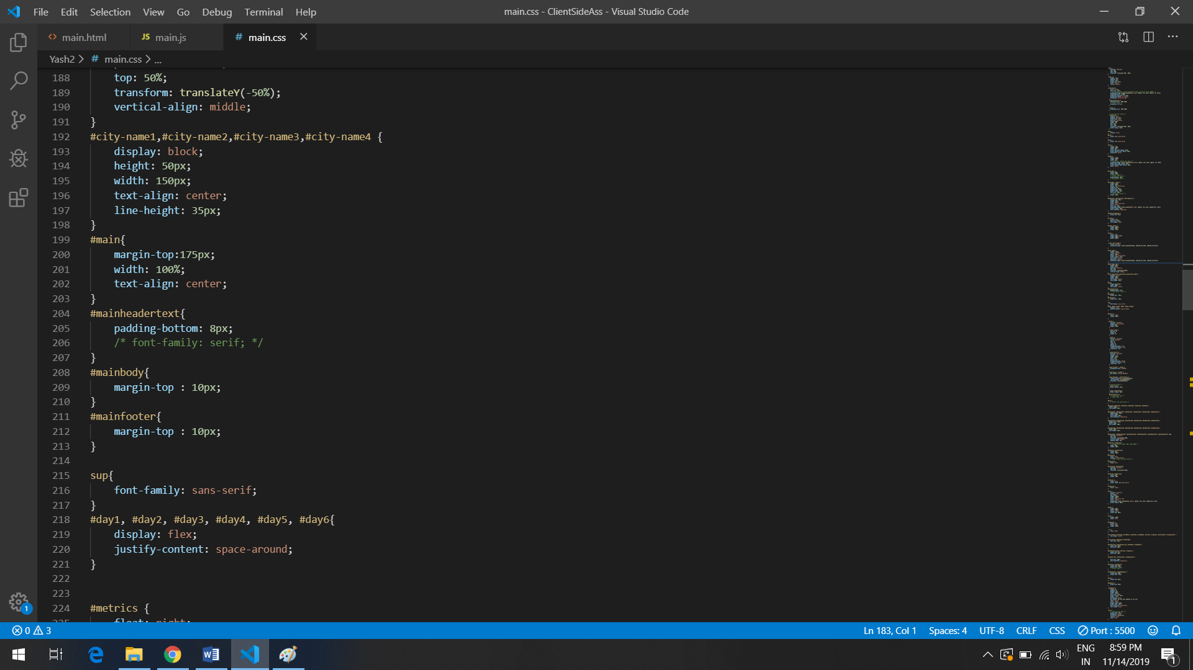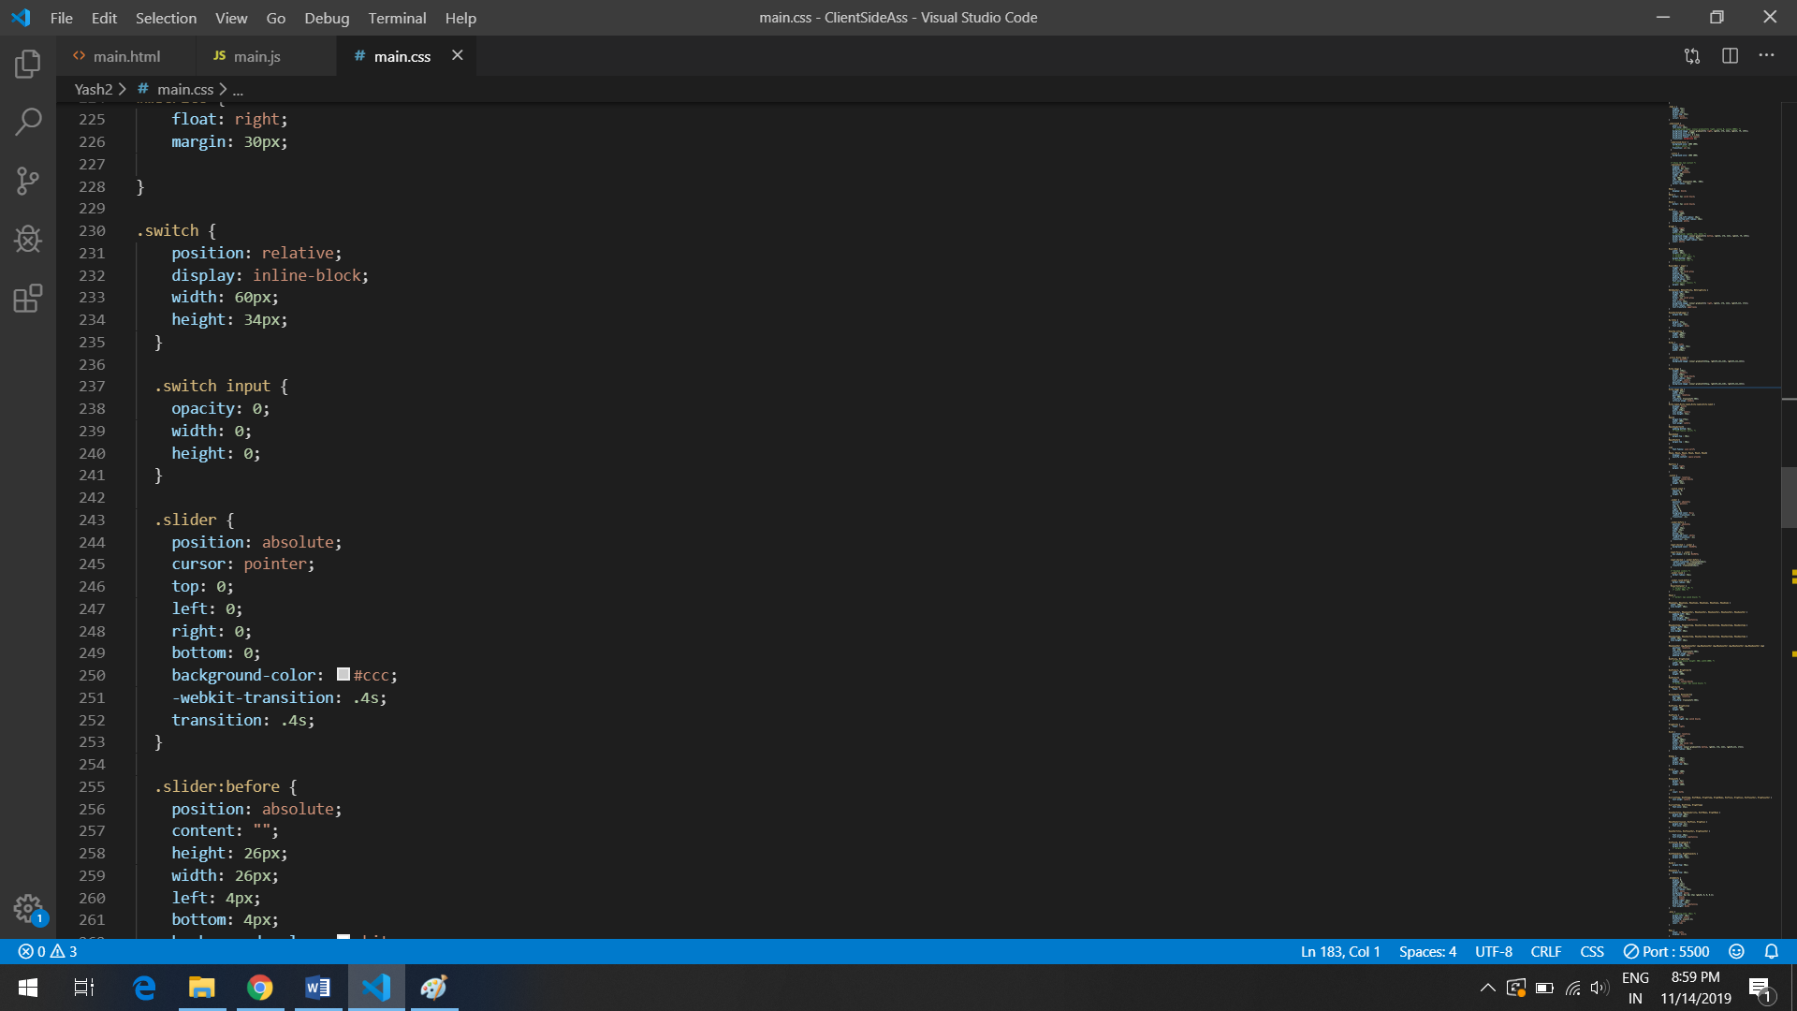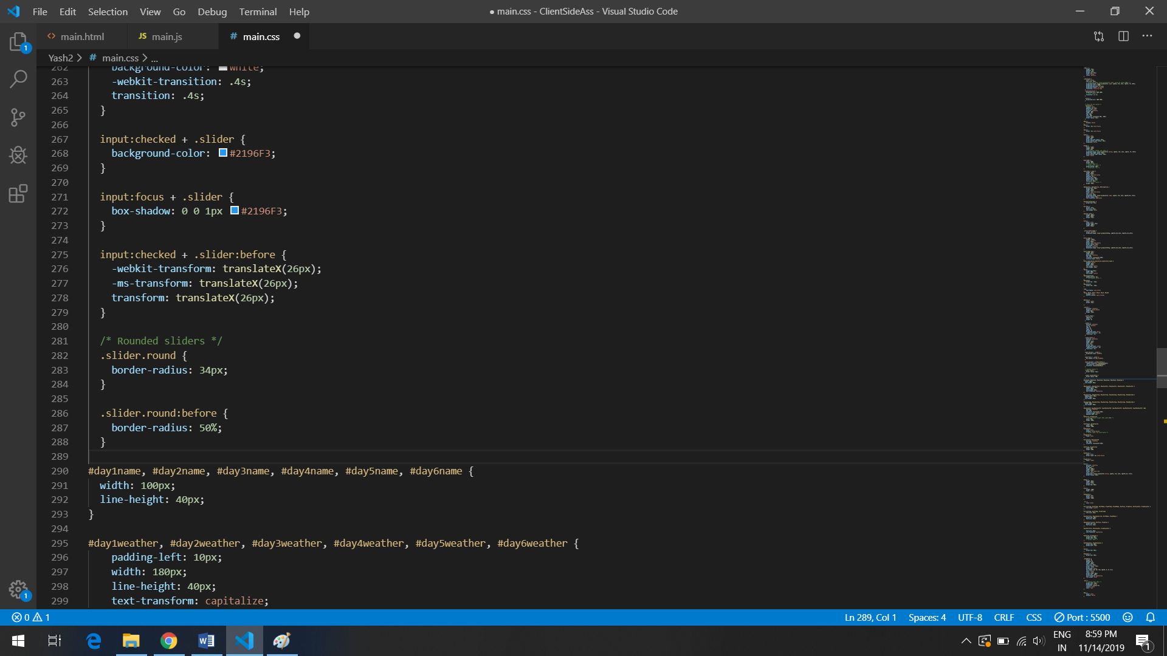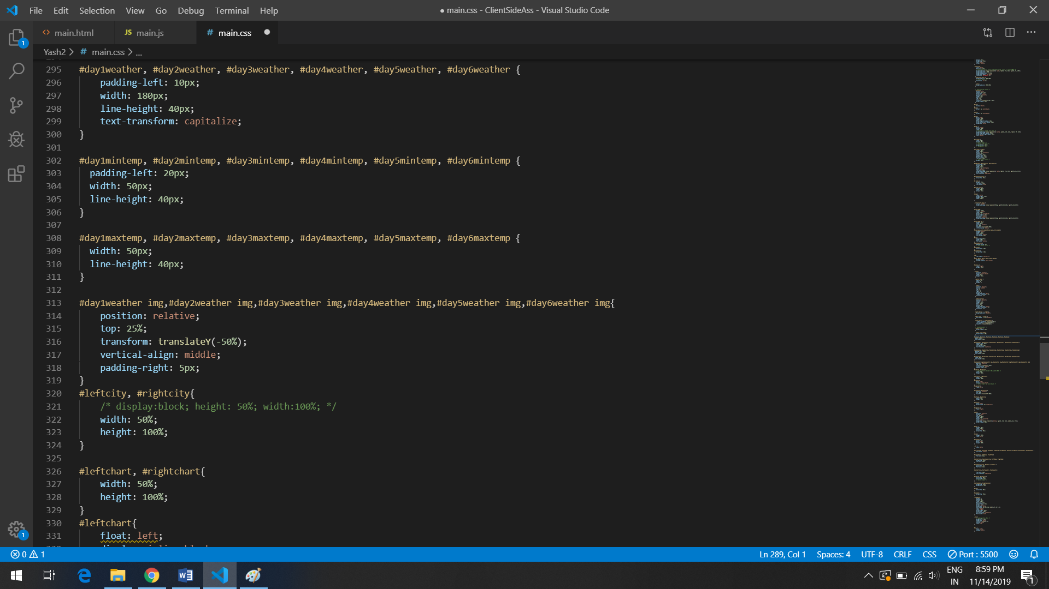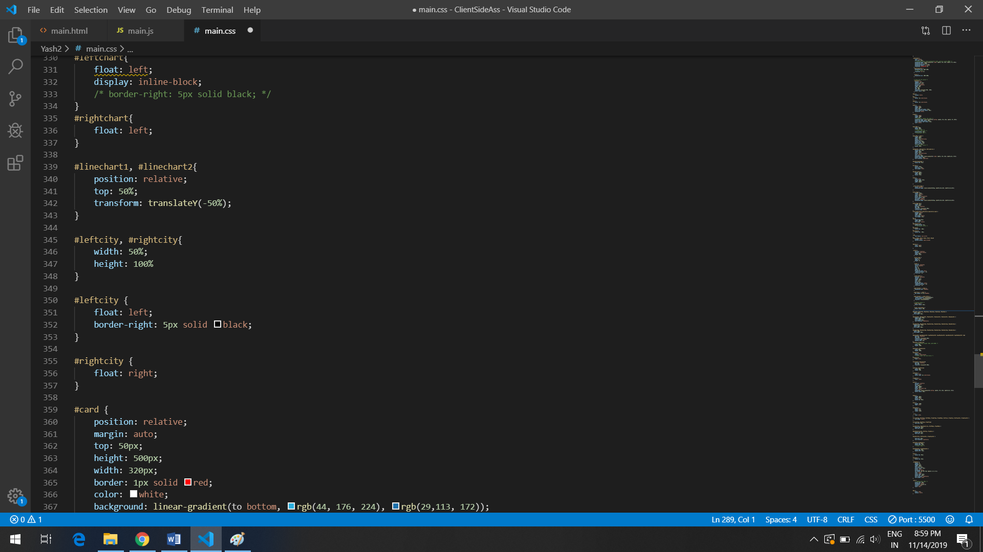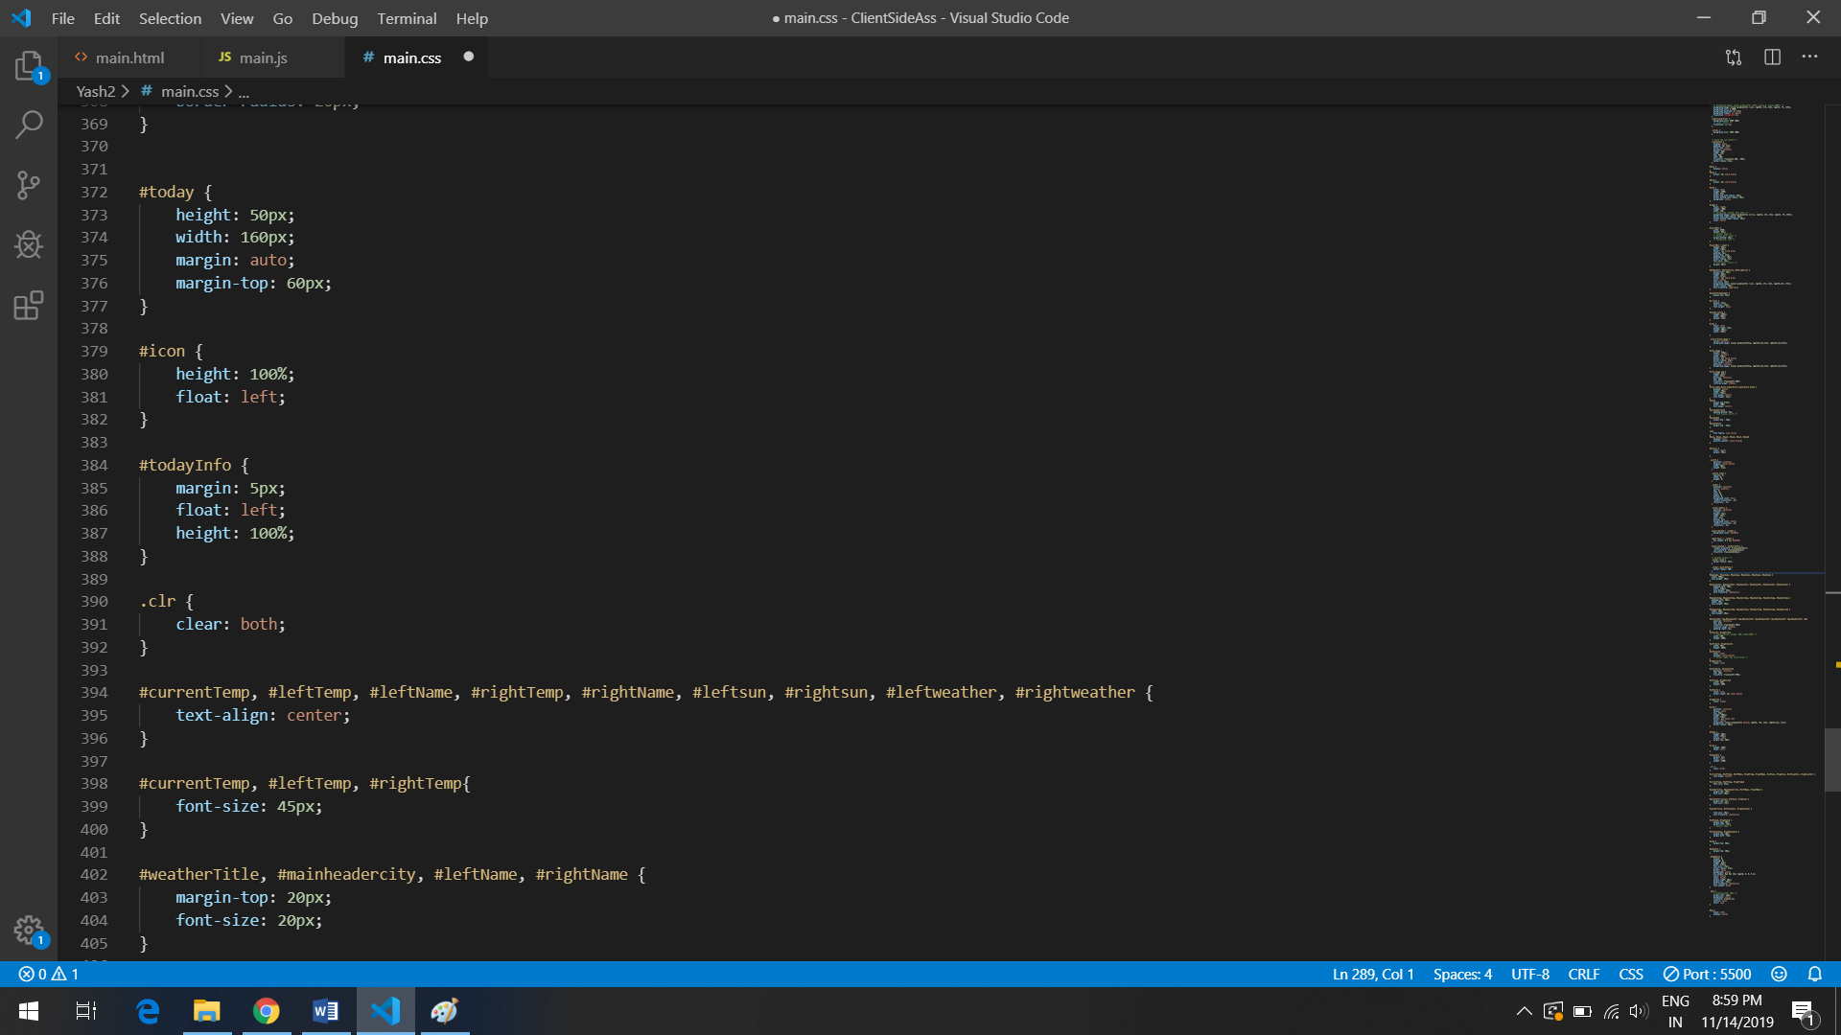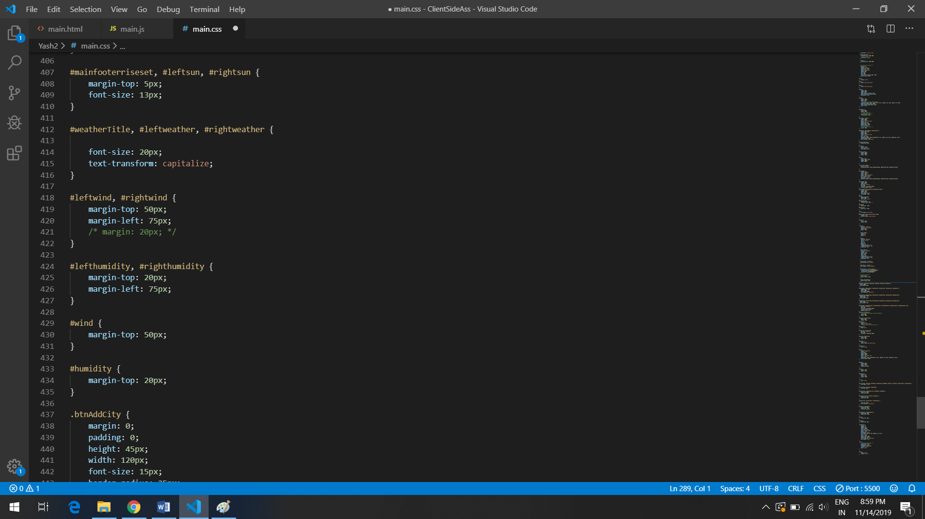

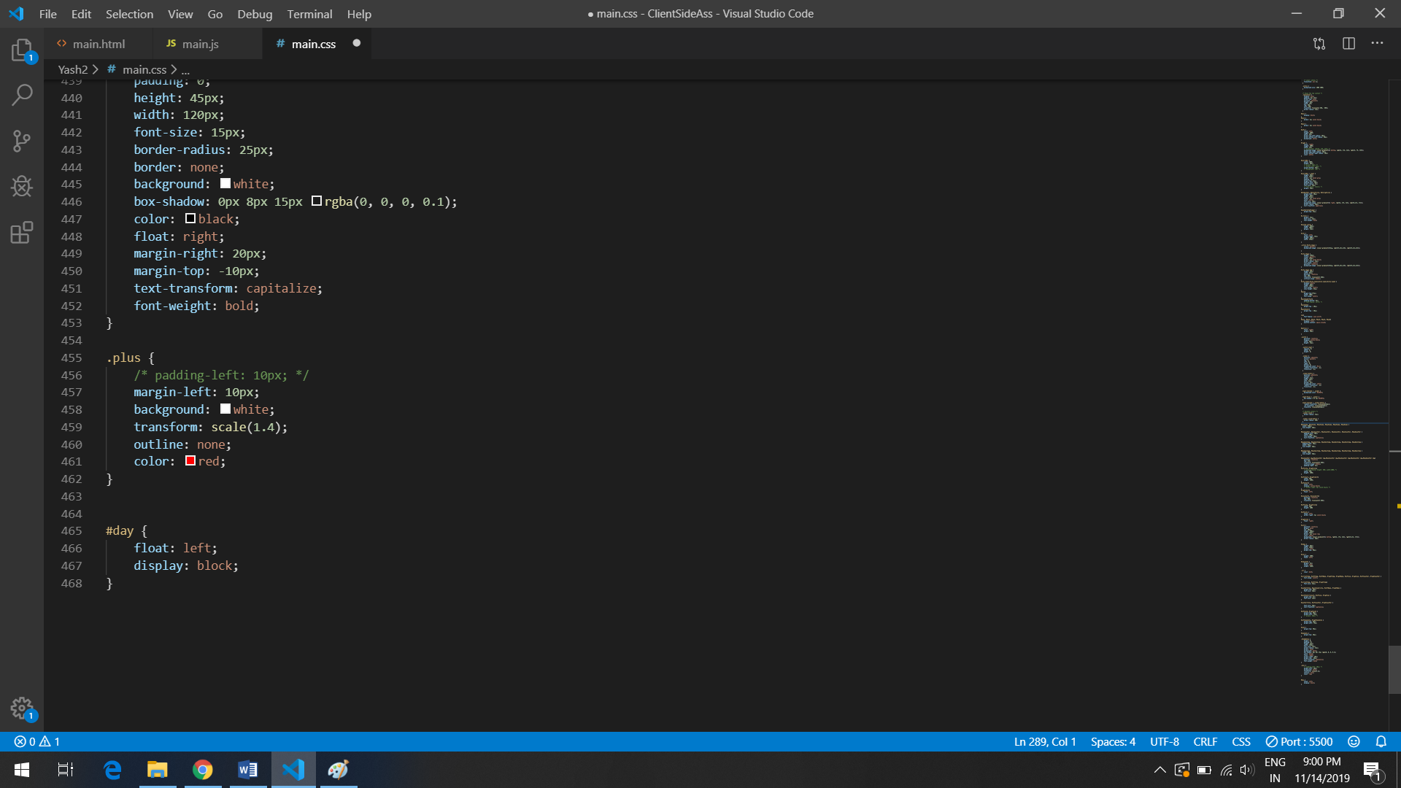

Outputs

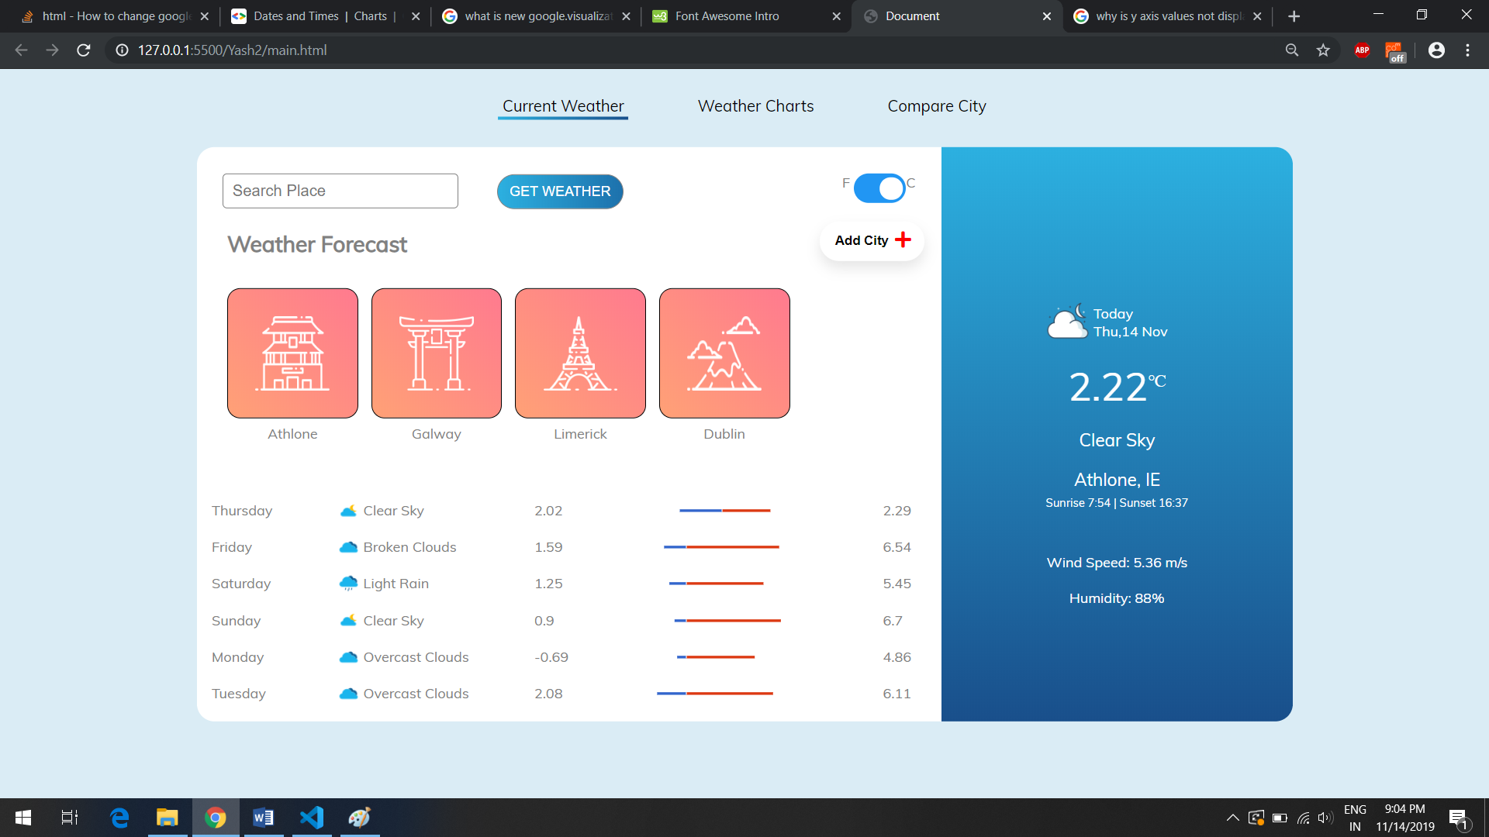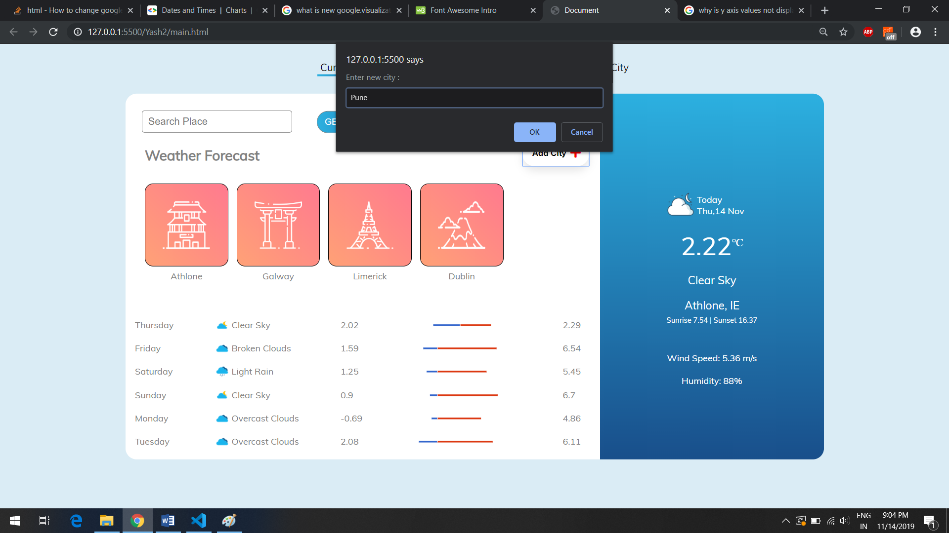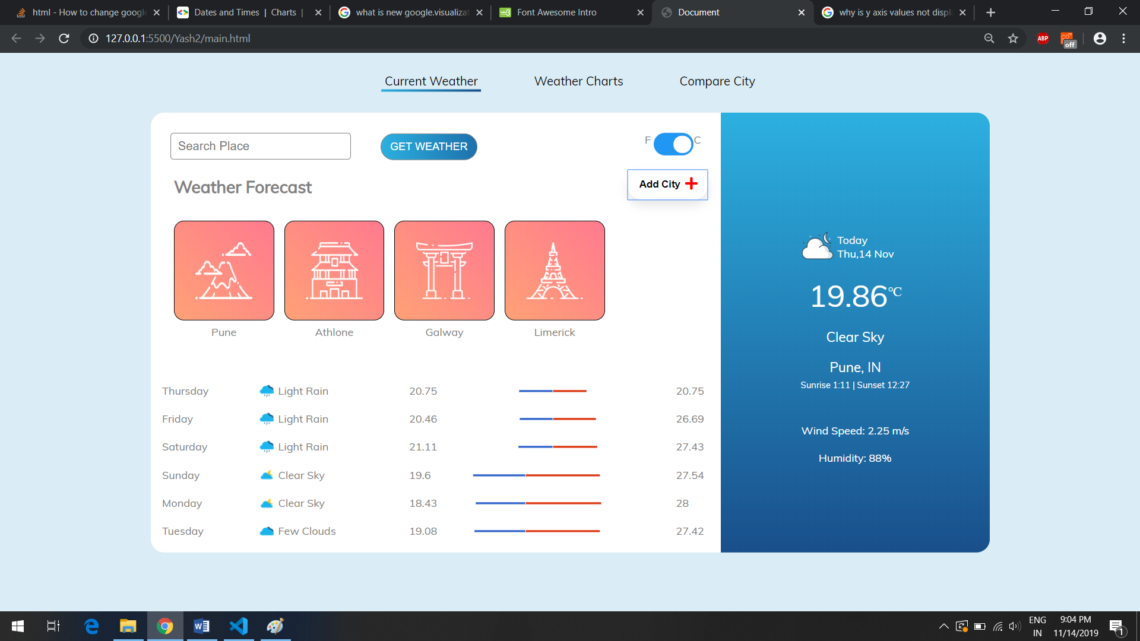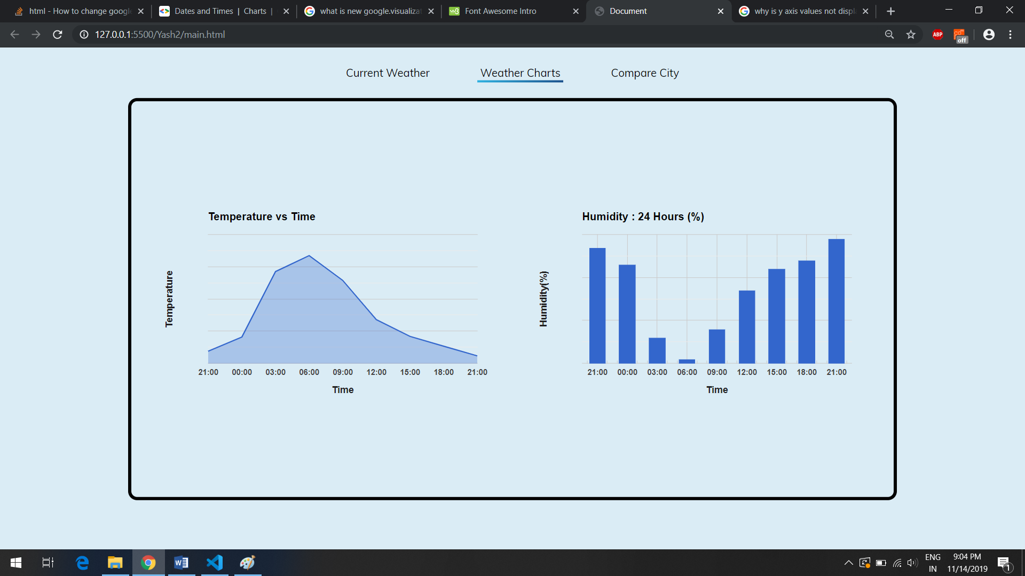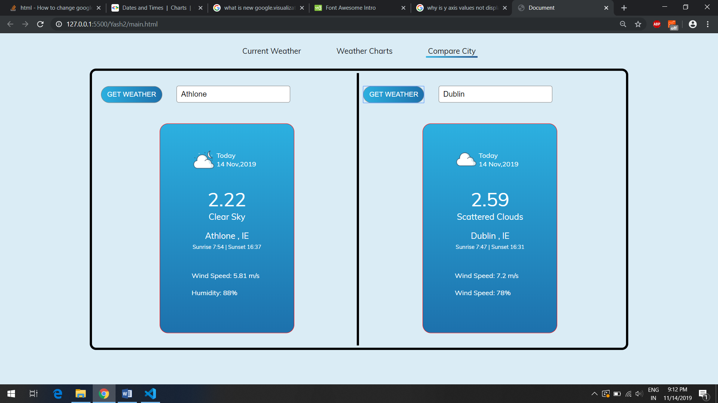

References:

1. <https://www.w3schools.com/default.asp>
2. <https://openweathermap.org/api>
3. <https://developers.google.com/chart>
4. <https://stackoverflow.com/>